Project Design Phase-II Technology Stack (Architecture & Stack)

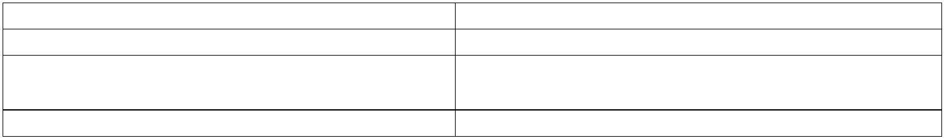

Date Team ID

Project Name

Maximum Marks

3 October 2022 PNT2022TMID17030

Project-Real time River water monitoring and control system

4 Marks

# Technical Architecture:

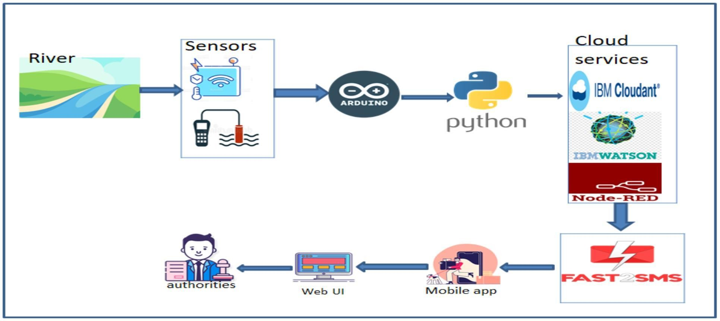

**Table-1 : Components & Technologies:**

# S.No Component Description Technology

1. User Interface How user interacts with application e.g. Web UI, Mobile App, Chatbot etc.

HTML, CSS, Node-Red ,Cloud,etc.

1. Application Logic-1
2. Application Logic-2
3. Application Logic-3
4. Database
5. Cloud Database

Logic for a process in the application Logic for a process in the application Logic for a process in the application Data Type, Configurations etc.

Database Service on Cloud

Java / Python

IBM Watson STT service IBM Watson Assistant MySQL, NoSQL, etc.

IBM DB2, IBM Cloudant etc.

1. File Storage File storage requirements IBM Block Storage or Other Storage Service or Local Filesystem
2. External API-1
3. External API-2
4. Machine Learning Model

Purpose of External API used in the application Purpose of External API used in the application Purpose of Machine Learning Model

IBM Weather API, etc. Aadhar API, etc.

Object Recognition Model, etc.

1. Infrastructure (Server / Cloud) Application Deployment on Local System / Cloud

Local Server Configuration: Cloud Server Configuration :

Local, Cloud Foundry, Kubernetes, etc.

# Table-2: Application Characteristics:

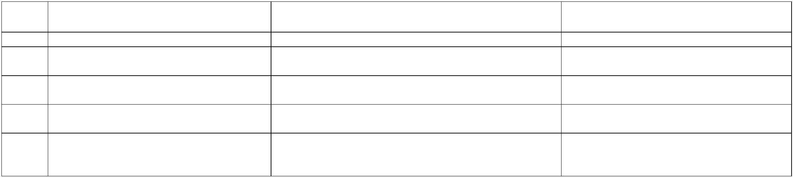

**S.No Characteristics**

**Description**

**Technology**

1. Open-Source Frameworks
2. Security Implementations
3. Scalable Architecture
4. Availability

List the open-source frameworks used

List all the security / access controls implemented, use of firewalls etc.

Justify the scalability of architecture (3 – tier, Micro-services)

Justify the availability of application (e.g. use of load balancers, distributed servers etc.)

Design consideration for the performance of the application (number of requests per sec, use of Cache, use of CDN’s) etc.

Technology of Opensource framework

e.g. SHA-256, Encryptions, IAM Controls, OWASP etc. Technology used

Technology used

5. Performance

Technology used